

**PRESS RELEASE** Prague, 26th May 2017

**PASSERINVEST GROUP opens the first part of the wooded park in Roztyly to the public**

**PASSERINVEST GROUP, a.s., as the owner of the land, has opened the first part of the wooded park near the Roztyly metro station (C line) to the public and organised an afternoon of sports and entertainment for families with children. The cleaned and revitalised area in the vicinity of the Nosál Hotel and Za Větrem Restaurant in Prague’s Roztyly district came to life with attractions and the laughter of children. There were fun disciplines, such as walking on slackline, archery and Discgolf, prepared for children and their parents.**

With this spring event PASSERINVEST GROUP, a leading Czech investment and development company, made the first part of its space, which will be a wooded park with an area of about 4 ha, available to the public. The leisure complex will contain meadows and groves, water and playground features and a sports area suitable for families with children, sports, relaxation or dog walking. Other plans for this locality and in the Interlovu complex can be seen here on three permanent information panels.

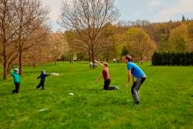

Children learned various Frisbee throws in the Roztyly Park and…

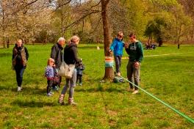

…they also walked along a slackline.

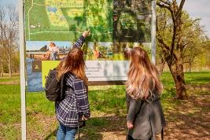

Visitors have the opportunity to see the future appearance of the area on the information panels

For more information and photographs in print quality please contact:

Kristýna Samková**,** Head of PR and Marketing dept.

**PASSERINVEST GROUP, a.s.**

Tel.: (+420) 221 582 111

Mobil: (+420) 602 186 708

E-mail: [Kristyna.Samkova@Passerinvest.cz](mailto:Kristyna.Samkova@Passerinvest.cz)

www.passerinvest.cz, [www.bbcentrum.cz](http://www.bbcentrum.cz)

Marcela Štefcová

**Crest Communications a.s.**

Mobil: (+420) 731 613 669

E-mail: marcela.stefcova@crestcom.cz

**About the Developer**

**PASSERINVEST GROUP, a.s.,** founded in 1991 by Radim Passer, is a purely Czech development and investment company whose name is associated in particular with the **BB Centrum** multifunctional complex in Prague 4 - Michle. With this project, the most successful and extensive Czech project of its type, the company has built its excellent reputation both at home and at the international level. Contributing to this is not only the high quality of the projects completed to date, but also its high level of service, its sense of fair play, its positive relationship with the tenants and users of its buildings, and its sense of responsibility towards society and the environment. **PASSERINVEST GROUP**’sportfolioincludes other interesting development projects.